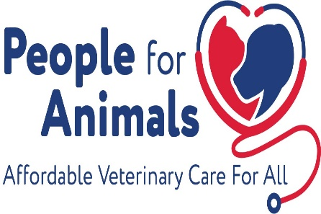
PFA’s Autumn Tricky Tray 2023 - Prepaid Reservations
For more information, email trickytray@pfaonline.org
Elks Lodge 1985 1 Perrin Ave Pompton Lakes, NJ
Friday Sept 15, 2023
Doors open at 5pm - Drawing 7pm - No one under 18 admitted
To raise funds to provided essential veterinary care to homeless animals and treasured family pets

Hundreds of baskets ranging in value from $40 to $500

Tier 1 $40 - $149 Tier 2 $150-$299 Supers $300-$500 50/50
Pricing: Admission only $10 includes 1 sheet Tier 1 Tickets

Prepaid Basic Package  $50 ($20 savings!)  - Admission ($10 value)  - 4 sheets Tier 1 tickets ($40 value)  - 5 Tier 2 tickets ($10 value)  - 2 SUPER tickets ($10 value) | Prepaid Deluxe Package  $70 ($30 savings!)  - Admission ($10 value)  - 6 sheets Tier 1 Tickets ($60 value)  - 10 Tier 2 tickets ($20 value)  - 2 SUPER tickets ($10 value)

ORDER FORM
Mailed checks must be received by 9/11/2023 to qualify for prepaid reservations.
Reservations available online until 5am on 9/15/2023 at https://pfaonline.org/events/ or until we reach capacity and are sold out. No outside alcohol and no one under 18 admitted.
Please list all members of your party. 1st person listed will be contacted to confirm reservation for group.

Name (first & last) | Phone | Email | Admission only $10 | Basic Package includes Admission  $50 | Deluxe Package includes Admission  $70 | Total Amount
Total Enclosed
Mail form & check(s) written to People for Animals to: Attention Tricky Tray, PFA 401 Hillside Ave. Hillside, NJ 07205

